**Expression of Interest in joining the KCCCC in 2022**

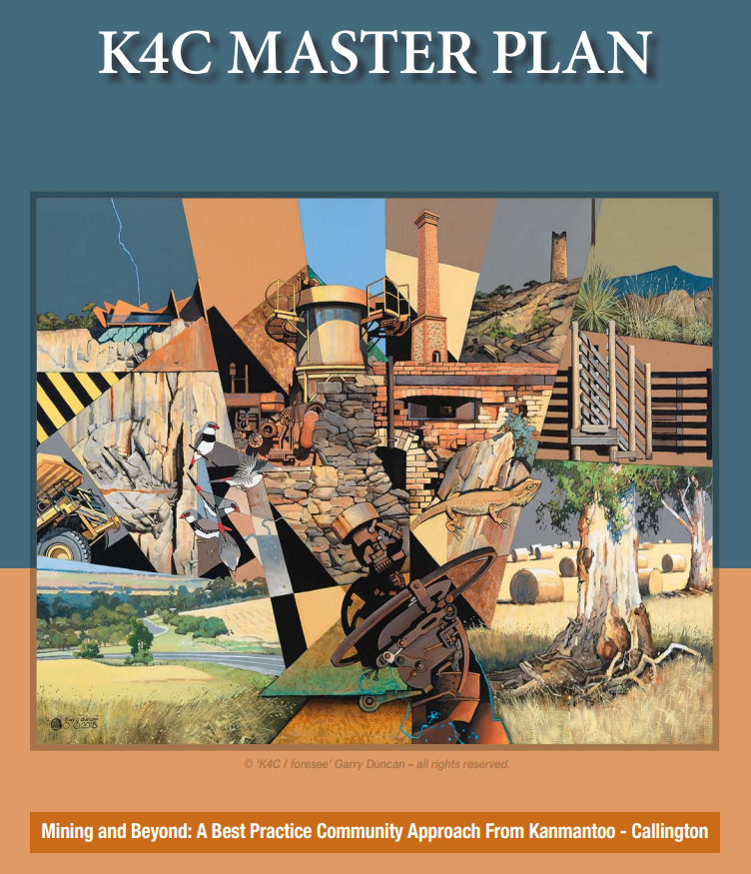The Kanmantoo-Callington Community Consultative Committee (KCCCC) provides an important community forum to consider relevant matters related to the Kanmantoo Copper Mine. The KCCCC brings together local community members and groups, Hillgrove Resources (the mining company), the Government’s mining regulator, agencies like EPA and SA Health, local councils, and a wide range of other stakeholders.

In October 2019 the*“K4C Master Plan – Mining and Beyond: A Best Practice Community Approach from Kanmantoo-Callington”*was launched*.*This Master Plan was developed as a joint collaborative project between the KCCCC and Hillgrove Resources. It demonstrates a leading approach for mining companies to engage with the communities in which they operate through the gathering and collation of community feedback over time.

Further information on the KCCCC and the Master Plan can be found at the below:

[www.kcccc.hillgroveresources.com.au](http://www.kcccc.hillgroveresources.com.au)

**KCCCC members and their particular areas of interest**

There are four project focus areas (Four pillars) of the K4C Master Plan:

* Environment
* Heritage
* Arts and Culture
* Economic Development

Committee members are encouraged to take a lead in particular areas of interests (portfolios) to ensure that the community’s views are well represented in these areas.

A call is now being made for residents of the districts of Kanmantoo and Callington with a particular interest in one or more of the above areas to join the KCCCC. We are seeking two representatives from each community to join us on the committee. To nominate yourself for the committee please fill out the attached form and return as per the instructions below or alternatively send a letter outlining your reasons for wishing to join.

We look forward to hearing from you!

Karlene Maywald - KCCCC Chairperson

Please complete the below form or write to us via post or e-mail to nominate for the KCCCC

|  |  |
| --- | --- |
| **Name:** |  |
| **Street address:** |  |
| **Postal address:** |  |
| **Contact Number:** |  |
| **Email:** |  |
| What is your particular **area of interest** in which you would be willing to take a lead on the Committee? (refer to the list above or include others if you feel they may be relevant) | |
| Please provide a **short description of the reasons** for your interest in joining the KCCCC and the particular skills, insights, experience and networks that you may bring to the role. | |
| **What happens next?**  We encourage you to come to our next KCCCC meeting on Thursday 16 June at 7:30 pm where you can see the KCCCC in action, meet others and ask questions. This should help you decide if the KCCCC is a group you would like to join. | |
| Submitting the completed Form:  |  |  | | --- | --- | | **Mail**  KCCCC Expression of Interest  Confidential  Secretariat Sonya Kitson  440 Mine Road, Kanmantoo SA 5252 | **Email**  [sonya.kitson@hillgroveresources.com.au](mailto:sonya.kitson@hillgroveresources.com.au)  Subject: KCCCC Nomination  **Phone**  8538 6800 to discuss other options | | |
| Expressions of Interest close at **5pm on Monday 27th June 2022** | |